**NATIONAL UNIVERSITY OF SCIENCES AND TECHNOLOGY**

**SCHOOL OF MECHANICAL & MANUFACTURING ENGINEERING (SMME)**

**CLASS:** BE Mechanical Sec-B (1st Semester)

**COURSE:** Computer Science & Programming

**LAB Home Task 2**

**TOPICS:** Grading, Divisibility, Leap Year, Scholarships & Vowels.

**INSTRUCTOR**: Sir Muhammad Affan

Submitted by Muhammad Rayyan

Roll no: 456847

Submission Date: 10-oct-2023

**Department of Manufacturing Engineering (DME)**

**CAD / CAM Lab**

// Q:01

//#include<iostream>

//using namespace std;

//

//int main(){

//

// int marks,grades; // declare variables

// cout<<"enter marks of student :"; //write what do you want to be shown on console

// cin>>marks; //write input

//

// if(marks>=90 && marks<=100) // write conditions of code

//

// {cout<<"grade wil be A"<<endl;} //printed statement on console if condition is true

//

// else if(marks>=75 && marks<90)

// {cout<<"grade will be B"<<endl;} //printed statement on console if else statement do not run

//

// else if (marks>=60 && marks<75)

// {cout<<"grade will be C"<<endl;} //printed statement on console if else 1 statement do not run

//

// else if (marks>=45 && marks<60)

// {cout<<"grade will be D"<<endl;} //printed statement on console if else 2 statement do not run

// else {cout<<"grade will be F"<<endl;} //printed statement on console if all if statements do not run

// return 0;

//}

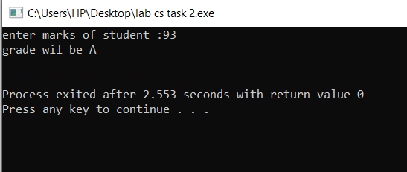

// Q:02

//int main(){

//

// int num; // declare variable

// cout<<"enter value of num :"; //write what do you want to be shown on console

// cin>>num; //write input

//

// if(num%2==0){ // write conditions of code

//

// if(num/5){ // write conditions of code

//

// cout<<"the num is even and divisble by 5"<<endl;} //printed statement on console if condition is true

//

//

// else {cout<<"the num is even but not divisible by 5"<<endl;}

//

// }

//

// else {cout<<"the number is not even nor divisible by 5"<<endl;} //printed statement on console if all if statements do not run

//

// return 0;

//}

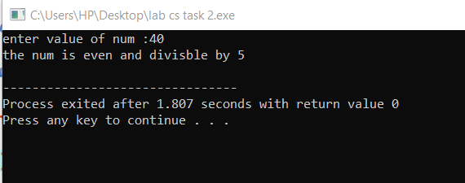

// Q: 03

//int main(){

//

// int year; // declare variable

// cout<<"enter a year :"; //write what do you want to be shown on console

// cin>>year; //write input

//

// if(year%4 == 0 && year/100 != 0) // write conditions of code

// {cout<<" its is a leap year"<<endl;} //printed statement on console if condition is true

//

//

// else {cout<<"its is not a leap year"<<endl;} //printed statement on console if all if statements do not run

//

// return 0;

//

//}

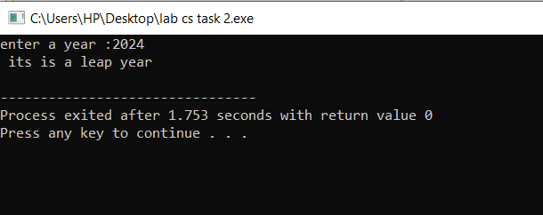

// Q: 04

//int main(){

//

// float gpa; // declare variable

// float attendance; // declare variable

//

// cout<<"enter gpa: "<<endl; //write what do you want to be shown on console

// cin>>gpa; //write input

//

// cout<<"ender attendance: "<<endl; //write what do you want to be shown on console

// cin>>attendance; //write input

//

// if(gpa >= 3.5 && attendance >= 80 ) // write conditions of code

//

// {cout<<"student is eligible for scholarship."<<endl;}

//

// else {cout<<"student is not eligible for scholarship"<<endl;} //printed statement on console if all if statements do not run

//

// return 0;

//

//}

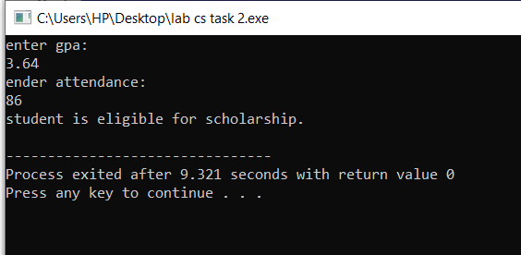

// Q: 05

// int main(){

//

// char alphabet; // declare variable

//

// cout<<"enter a alphabet:"<<endl; //write what do you want to be shown on console

// cin>>alphabet; //write input

//

// char vowel= (alphabet == 'a'|| alphabet == 'e'|| alphabet == 'i'|| alphabet == 'o'|| alphabet == 'u');

//

// if(alphabet = vowel ) // write conditions of code

// {cout<<" the aphabet is vowel."<<endl;} // write statement that u want to be shown on console if conditions fulfill

//

// else{cout<<"the alphabet is a consonant."<<endl;} //printed statement on console if all if statements do not run

//

// return 0;

// }

